Stages of Birth – Notes
- Gestation: The time that the embryo or foetus is carried in the uterus.
- During this period, the developing child grows to a length of around 50cm and average weight of 3400g – this takes around 280 days, measured from thew beginning of the menstrual period.
- Parturition: The process by which the foetus is expelled from the mother’s body at the end of gestating (birth).
- Parturition is preceded by a sequence of events commonly called labour.

- In preparation for labour, hormonal changes cause the ligaments of the pelvis to soften, making them more pliable for childbirth; hormonal changes also increase the response of the uterus to stimuli and strengthen contraction of its muscles.
- Before labour begins, the cervix has softened, shortened in length and is likely to begin to open a little.

First Stage of Labour – Notes
Labour pains:
- During the final 3 months of gestation, the uterus undergoes weak, irregular contractions that become stronger and more frequent during the final weeks of pregnancy.
- Contractions are strong and occur every 30 minutes.
- This is the beginning of the birth process.

Dilation of the cervix:
- The time from the onset of labour to complete dilation of the cervix.
- Lasts around 8-9 hours for the first labour and 4 hours for the birth of subsequent children.
- Waves of contraction travel from the outer part of the uterus downwards toward the cervix. This pull on the cervix shortens it so that it no longer projects down into the vagina.
- At the same time the cervix dilates which allows the foetus to move more deeply into the pelvis.
- Foetus’s head is pushed more forcefully against the dilating cervix with increasing frequency and strength of contractions.
- Eventually the cervix is completely dilated (10cm) and the uterus, cervix, and vagina form a single curved passage called the birth canal.
- Complete dilation of the cervix marks the end of the first stage of labour.
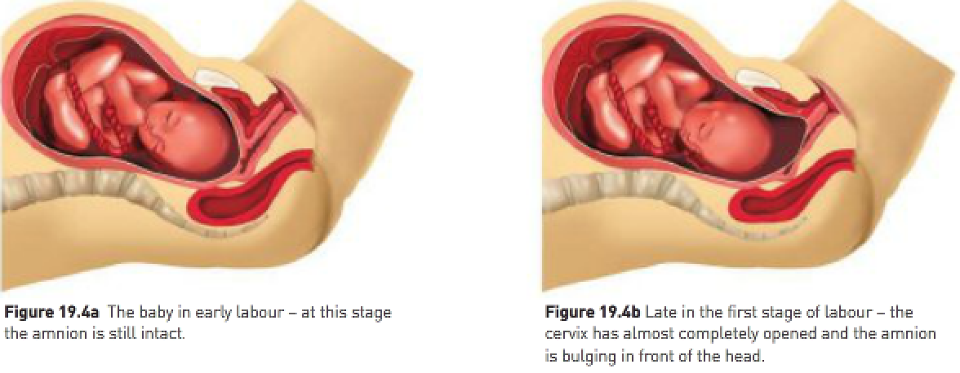
Second Stage of Labour – Notes
Stage of expulsion:
- Involves the delivery of the foetus.
- Begin with the bursting of the membrane surrounding the foetus and a gush of fluid from the vagina.
- Occurs at the beginning of the second stager of labour (in most cases).
- Lasts from 20 minutes to 2 hours from full dilation of the cervix to birth.
- As the foetus travels through the fully dilated cervix, the head stretches the vagina which stimulates the woman to contract her abdominal muscles.
- These contractions, together with the contractions of the uterus, push the foetus through the vagina.
- The head of the foetus is downwards in over 90% of births.
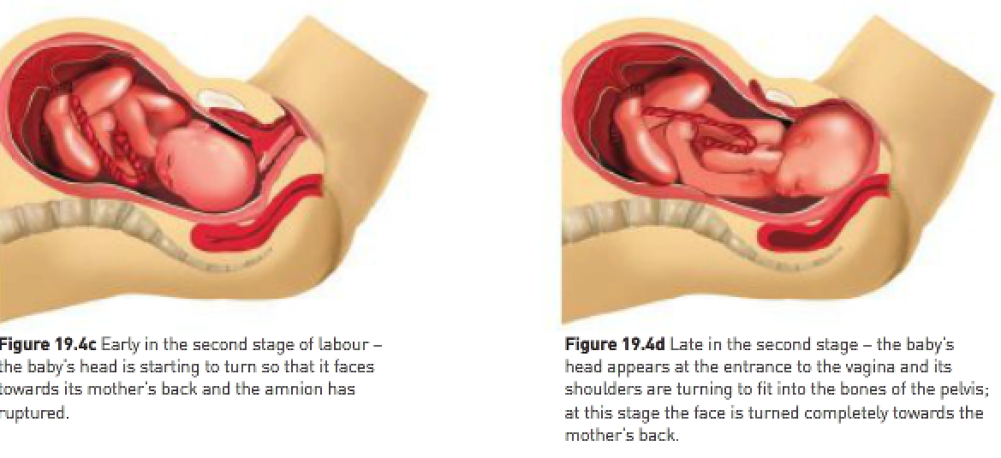
Third Stage of Labour – Notes
- Once born, the baby begins to breathe with its own lungs.
- The foetus is still connected to the placenta by the umbilical cord.
- The amnion, chorion and placenta are still inside the uterus.
- Umbilical cord is clamped, tied in 2 places and cut between the ties; umbilical arteries and vein contract either before or immediately after they’re cut and then dry up over a few days to become the navel (umbilicus).
- At birth the baby is covered in a waxy material called the vernix; it’s common to clean the baby with a cleansing agent that doesn’t remove all the vernix.
- The uterus continues to contract and around 5 minutes after delivery of the placenta, other membranes and remains of the umbilical cord are expelled (afterbirth).
- Little blood is lost at this stage because placental blood vessels constrict, and uterine contractions shut the uterine vessels that supply blood to the placenta.
- Blood clots form to stop all leakage of blood.
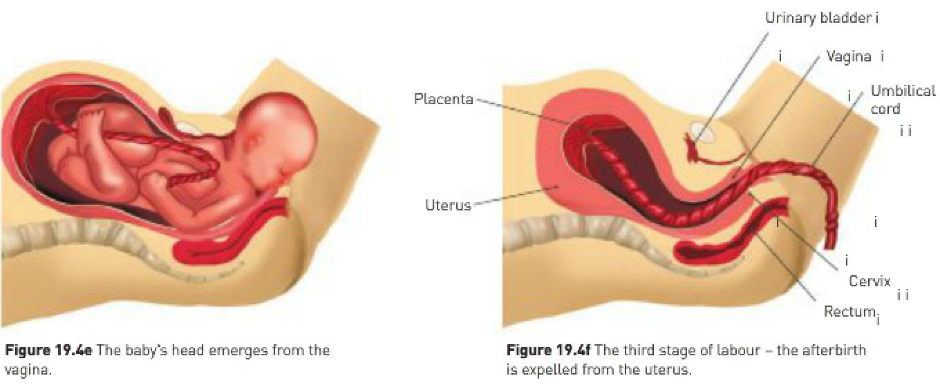
Characteristics of the newborn infant:
- At birth, full-term babies are on average 50cm long and weigh 3.4kg.
- The head makes up one quarter of the overall length and the legs one third.
- If held vertically under the arms, the head lolls forward and the bowed legs hang helplessly.
- It can suck, breathe, swallow and excrete.
- Reflexes govern most of the movements of newborn babies.

Changes in the baby at birth:
- The baby’s blood is carried to the placenta in 2 umbilical arteries; as it circulates through the placenta, CO₂ and other wastes are exchanged for oxygen and nutrients.
- The blood then returns to the foetus via the umbilical vein.
- Some of the blood returning to the foetus flows through the liver and into the inferior vena cava (the main vein taking blood to the heart from the lower body).
- The remainder bypasses the liver by flowing through a vessel called the ductus venosus and then into the inferior vena cava.

Blood returning to the foetal heart enters the right atrium. From there it can follow several pathways:
- Blood may flow into the right ventricle and then to the lungs in the usual way. Note: Lungs are collapsed and not functioning so they offer considerable resistance to blood flow and little blood reaches the lungs.
- Most of the blood from the right ventricle flows through the ductus arteriosus to the aorta (carries blood to the body); the ductus arteriosus is a lung bypass that allows blood in the pulmonary artery (carries blood to the lungs) directly into the aorta.
- Blood in the right atrium of the heart may flow directly into the left atrium through an oval opening between the 2 chambers (foramen ovale); this is beneficial as the blood coming from the placenta is highly oxygenated and can flow to the developing foetal tissues via the aorta very quickly.

First breath of life is triggered by:
- The shock of birth.
- Slap on the baby’s bottom as a stimulus to start breathing.
- Clamping of the umbilical vessels which increases CO₂ levels in the baby’s blood to rise to stimulate the respiratory centre in the brain.

Changes in the circulation at birth:
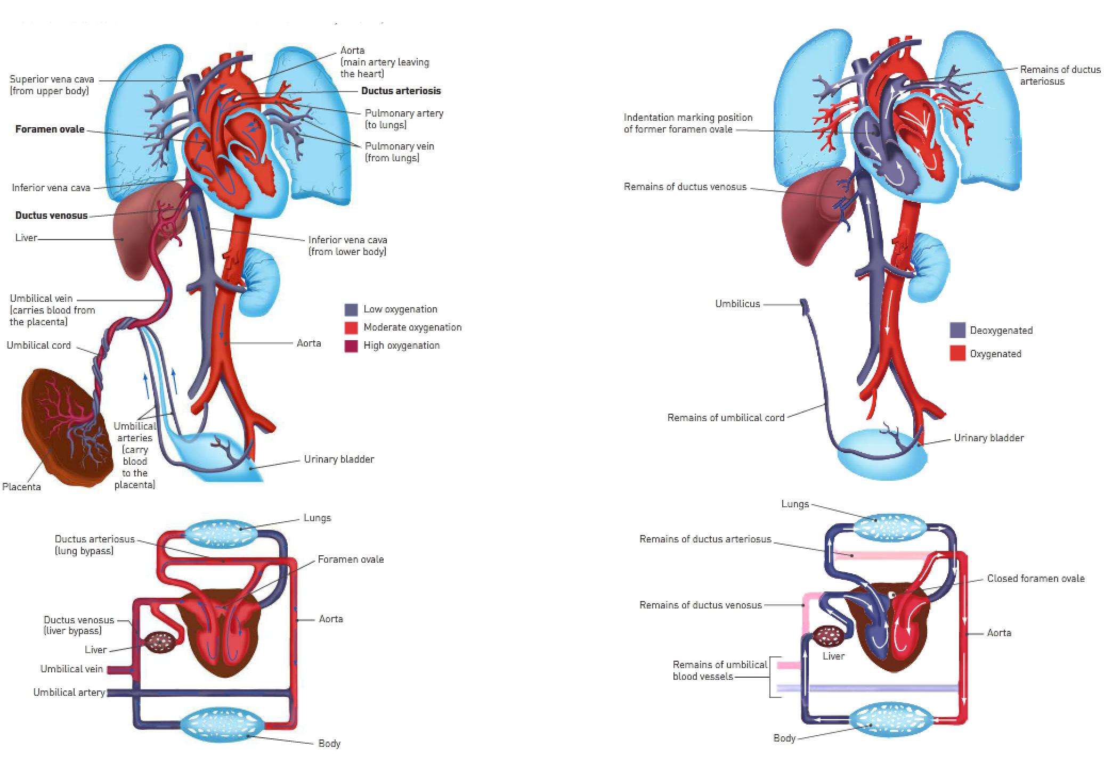
- As the lungs expand, they no longer offer the same resistance to blood flow.
- Blood flow through the ductus arteriosus begins to decrease.
- A few weeks after birth, all that’s left of the ductus arteriosus is some fibrous tissue.
- As more blood returns to the heart from the lungs, the pressure in the left atrium increases.
- This forces the flap of the foramen ovale against the wall of the atrium, closing off the opening.

Changes to the mother after childbirth:
- Reproductive organs (particularly the uterus) slowly return to their non-pregnant state – this period is called the puerperium.
- Uterus continues to contract after delivery.
- Within 2 weeks the mother no longer feels the swelling of her abdomen.
- Uterus has completed shrinking at the end of puerperium; this is brought about by contractions and gradual shrivelling of muscle fibres; this flattens the abdomen.
- Discharge of fluid from the slowly shrinking uterus, a mixture of blood and breakdown products of tissues; usually stops after 3 weeks.
- Blood volume reduces to normal.
- Pulse is slower and the body temperature slightly above normal.
- The return of menstruation shows that the reproductive system is back to normal.
_____
- When labour starts, contractions are felt.
- With some women the water breaks and then they begin to have contractions.

First stage of labour:
- Cervix dilates from closed (normal state) to fully open (10cm in diameter).
- Note: – This stage lasts 12-16 hours if it’s the first child.
- For second or subsequent children, the first stage lasts 6-7 hours.

Phases of the first stage:
- Early labour (dilation up to 4cm).
- Active labour (4-8cm).
- Transition (8-10cm).

Early labour (stage 1):
- Leaking of the amniotic fluid may occur at this stage.
- The expulsion of the plug that has kept the cervix sealed occurs.
- Contractions in early labour become regular in their occurrence, 10-20 minutes apart and lasting 30-60 seconds.
- Amniotic sac is usually intact.
- Cervix thins.
- Early labour is (on average) half the labour time (2-20 hours).

Active phase (stage 1):
- Contractions become regular and increase in frequency.
- Contractions are now 3-5 minutes apart and last longer (60-90 seconds).

Transition phase (stage 1):
- Transition phase is the hardest and most intense.
- It’s the shortest of the 3 stages and most intense.
- It’s the shortest of the 3 stages, lasting 10-45 minutes.
- Contractions occur every 2 minutes or so and each one lasts a minute or more.

Second stage of labour – birth:
- The body’s head well appears.
- The second stage of labour usually takes a couple of hours for new mums.

Third stage of labour:
- Occurs between 5 minutes to one hour after the baby is born.
- This involves contractions that deliver the placenta and membranes.
- These contractions are milder.

Birth Triggers – Notes
Starting the birth process:
- The foetus’s head pushes onto the cervix.
- The cervix releases nerve impulses that travel to the hypothalamus that’s located in the brain.
- The hypothalamus causes the pituitary gland to release oxytocin.
- Oxytocin causes uterine walls to contract.
- The foetus’s head pushes on the cervix and the cycle begins again.

